Network Security Groups

Azure NSGs are used to filter network traffic to and from resources in an Azure virtual network
Subnet level network and application access control

NSG Limits
limits are applied per region per subscription:
- 5000 NSGs per subscription
- 1000 Rules per NSG
- 4000 IP’s or ranges specified per NSG

NSG Rules Components
- Name: name with purpose of NSG rule
- Priority rang is 100-4096. Low number processed before higher
- Source: Any IP address or CIDR or Service tag or Application security group
- Destination: Any or IP address or CIDR or Service tag or Application security group
- Protocol: TCP, UDP, ICMP, SMTP, SSH, RDP, FTP, or any
- Direction: Inbound or Outbound
- Port Range: Individual or range of ports, 22, 3389, 100-110
- Action: Allow or Deny

Rule Name | Priority | Source | Source Port | Destination | Destination Port | Protocol | Access | Direction
Name | 100-4096 | Any,  IP/CIDR,  Service Tag,  App security group | 0-65535 | Any,  IP/CIDR,  Service Tag,  App security group | 0-65535 | Any,  TCP,  UDP,  ICMP | Allow,  Deny | Inbound,  Outbound

NSG Workflow
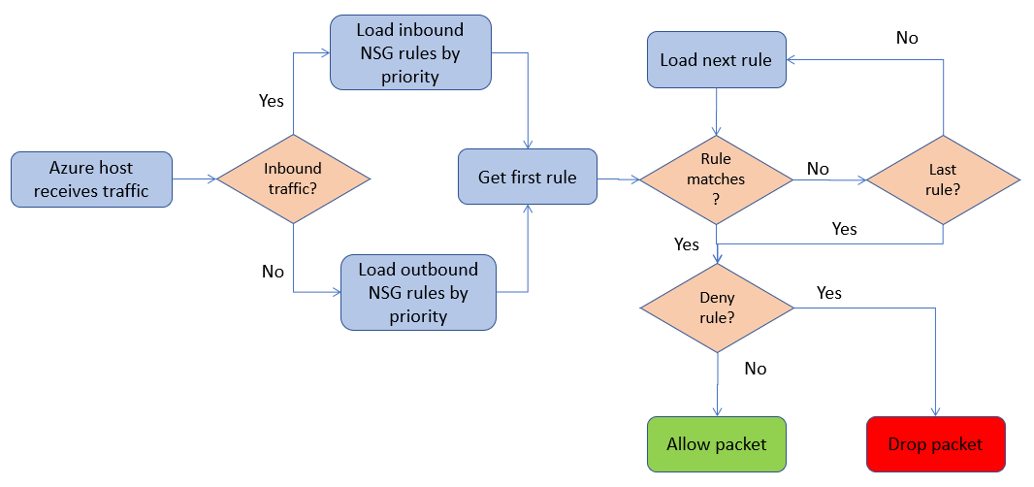

Default NSG Rules

Inbound Rules:

Rule Name | Priority | Source | Source Port | Destination | Destination Port | Protocol | Access
AllowVNetInBound | 65000 | VirtualNetwork | 0-65535 | VirtualNetwork | 0-65535 | Any | Allow
AllowAzureLoadBalancerInBound | 65001 | AzureLoadBalancer | 0-65535 | 0.0.0.0/0 | 0-65535 | Any | Allow
DenyAllInbound | 65500 | 0.0.0.0/0 | 0-65535 | 0.0.0.0/0 | 0-65535 | Any | Deny

Outbound Rules

Rule Name | Priority | Source | Source Port | Destination | Destination Port | Protocol | Access
AllowVNetOutBound | 65000 | VirtualNetwork | 0-65535 | VirtualNetwork | 0-65535 | Any | Allow
AllowInternetOutBound | 65001 | 0.0.0.0/0 | 0-65535 | Internet | 0-65535 | Any | Allow
DenyAllOutbound | 65500 | 0.0.0.0/0 | 0-65535 | 0.0.0.0/0 | 0-65535 | Any | Deny

Sample NSG Rules

Network rule collection group
- Priority: 100
- Rule collection action: Allow

Name | Source type | Source | Protocol | Ports | Destination type | Destination
Rule-1 | IP/CIDT/IP group | *, 10.0.0.0,  172.16.0.0 | TCP, UDP, ICMP, Any | 80, 150-155 | IP/CIDR/IP group  Service tag/FQDN | *, 10.0.0.0,  172.16.0.0/24
Test-1 | IP_Address | 10.0.0.0 | TCP | 80 | IP address
Test-2 | IP Group | ipgroup-oracleappserver | TCP | 443 | Service tag
Test-3 | IP_Address | 10.0.0.0 | UDP | 150 | IP Group
Test-4 | IP Group | ipgroup-oracleappserver | UDP | 135 | FQDN

Application rule collection group
- Priority: 101
- Action: Allow

Name | Source type | Source | Protocol | TLS Inspection | Destination type | Destination
Rule-1 | IP/CIDR/IP group | *, 10.0.0.0, 172.16.0.0 | HTTP/HTTPS,  FTP/FTPS  RDP/SSH | 80, 150-155 | FQDN/FQDN tag  Web URL/Categories | *, 10.0.0.0, 172.16.0.0/24
Test-1 | IP_Address | 10.0.0.0 |  | 80 | FQDN | *.microsoft.com
Test-2 | IP Group | ipgroup-oracleappserver |  | 443 | FQDN tag
Test-3 | IP_Address | 10.0.0.0 |  | 150 | URL | www.microsoft.com
Test-4 | IP Group | ipgroup-oracleappserver |  | 135 | Web Categories

DNAT rule collection group
DNAT stands for Destination Network Address Translation.
- Priority:
- Action: Allow

Name | Source type | Source | Protocol | Destination port | Destination type | Destination | Translated type | Translated address or FQDN | Translated port
1 | IP/CIDR/ IP group | *, 10.0.0.0,  172.16.0.0 | HTTP  RDP  FTP  SMTP | 80, 150-155 | IP address, FQDN | *, 10.0.0.0,  172.16.0.0/24
1 | IP Address | 10.0.0.0 |  | 80 | IP address | 172.16.0.0
2 | IP Group | ipgroup-oracleappserver |  | 443 | IP address | 172.16.0.0
3 | IP Address | 10.0.0.0 |  | 150 | FQDN | *.microsoft.com
4 | IP Group | ipgroup-oracleappserver |  | 135 | FQDN | *.microsoft.com

Logging and Monitoring

Design and Implementation

How to design and implement NSG and ASG?

Application Security Group

What is ASG and how to design and implement ASG?

Securing azure network with segmentation and access Control
There are several methods for securing your Azure cloud network using network segmentation and access control mechanisms.

Key Points:
- Azure Virtual Networks (VNets) and Subnets:
  - VNets and subnets are the building blocks for network segmentation.
  - You can isolate high-risk or high-value resources in separate VNets or subnets.
- Network Security Groups (NSGs):
  - NSGs act as firewalls, controlling traffic flow based on rules defined for ports, protocols, source, and destination IP addresses.
  - Follow a "deny-by-default" approach with NSGs, explicitly allowing only authorized traffic.
  - Application Security Groups (ASGs): For complex applications, ASGs simplify NSG configuration by grouping VMs and defining security policies based on those groups.
- Azure Policies:
  - Azure policies enforce security best practices within your Azure environment.
  - The passage recommends specific policies like:
    - Restricting all network ports on VM-associated NSGs.
    - Disabling IP forwarding on VMs.
    - Routing all internet traffic through a deployed Azure Firewall (preview).
- Securing Cloud Services with Private Endpoints:
  - Azure Private Link enables private access to Azure services within your VNet, bypassing the public internet.
  - This reduces the attack surface and strengthens security.

Additional Resources:
- VNet concepts and best practices: https://learn.microsoft.com/en-us/azure/virtual-network/
- Network Security Groups: https://learn.microsoft.com/en-us/azure/virtual-network/manage-network-security-group
- Application Security Groups: https://learn.microsoft.com/en-us/azure/virtual-network/application-security-groups
- Azure Private Link: https://learn.microsoft.com/en-us/azure/private-link/
- Security architecture: https://learn.microsoft.com/en-us/azure/security/
By implementing these network segmentation and access control techniques, you can significantly improve the security posture of your Azure cloud environment.

Secure cloud services with network controls (Private Endpoints)
- Secure cloud services by establishing a private access point for the resources. You should also disable or restrict access from public network when possible.
- Deploy private endpoints for all azure resources that support the Private Link feature, to establish a private access point for the resources. You should also disable or restrict public network access to services where feasible.
- For certain services, you also have the option to deploy VNet integration for the service where you can restrict the VNET to establish a private access point for the service."

Azure Policy
- Adaptive network hardening recommendations should be applied on internet facing virtual machines
- All Internet traffic should be routed via your deployed Azure Firewall
- All network ports should be restricted on network security groups associated to your virtual machine
- Azure Firewall Led the security assessment of azure security services such as Azure Firewall
- Configure diagnostic settings for Azure Network Security Groups to Log Analytics workspace
- Configure network security groups to enable traffic analytics
- Configure network security groups to use specific workspace for traffic analytics
- Deploy a flow log resource with target network security group
- Finding the most efficient way to implement firewall policies across Contoso's multiple Azure regions.
- Flow logs should be enabled for every network security group
- Gateway subnets should not be configured with a network security group
- Internet-facing virtual machines should be protected with Network Security Groups
- IP Forwarding on your virtual machine should be disabled
- Management ports of virtual machines should be protected with just-in-time network access control
- Management ports should be closed on your virtual machines
- Network Watcher flow logs should have traffic analytics enabled
- Non-internet-facing virtual machines should be protected with network security groups
- NSG Led the security assessment of azure security services such as network security groups,
- Secured Virtual Hubs and Hub Virtual Networks.
- Subnets should be associated with a Network Security Group
- Virtual network design considerations and configuration options for Azure Active Directory Domain Services

Understand Azure Private Link: https://docs.microsoft.com/azure/private-link/private-link-overview
Security architecture: https://docs.microsoft.com/azure/cloud-adoption-framework/organize/cloud-security-architecture

Best practices

